**Apriori**

Apriori :- Apriori means deriving one thing from another thing on the basis of some relationship.

Ex1 :- Let’s take example of flipkart. If someone is willing to buy a shirt then, most probably he will buy pant too, or else he can buy few more thing which is related to clothes.

Remember, He can buy some other things also but from Fliplkart perception it’s important for them to keep track of behaviour of his customer so that, they keep the most demanding materials in stock and fasten their delivery services.

That’s how flipkart, Google, amazon, etc tracks our behaviour and refer us those products which we can buy.

Ex 2 :- If we search any horror movie on Youtube then, youtube starts suggesting horror related movies. So, They tracks us with the help of Apriori algorithm.

EX 3 :- There are 4 movies in cinema hall. People who has watched Movie1 are willing to watch Movie2 also. People who has watched Movie 3 has also watched Movie 1 and People who has watched Movie 1 are also willing to watch Movie 4.

Working of Apriori Algorithm,

Apriori algo. Is divided into 3 processes,

1. Support
2. Confidence and
3. Lift

Support = Total number of product or samples / Total no. Of Event.

Considering Movie Example,

Support( Movie1 ) = 10( In a group, 10 people has watched movie 1 )/ 100( out of 100 )

= 0.1 or 10%

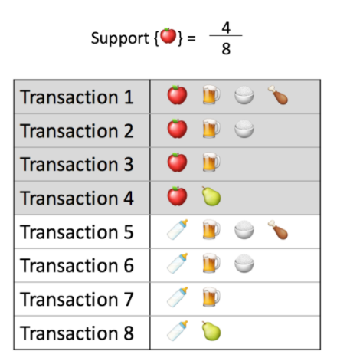

Confidence( Object1 -> Object2 ) = Total( Object1 -> Object 2 ) / Total( Object 1 )

Confidence( Movie1 -> Movie2 ) = Total( Movie1 -> Movie2 ) / Total( Movie1 )

= 4/10 = 0.4 or 40%

=40% x 10% = 0.4 x 0.1 = 0.04





Lift( Movie 2 ) = 40%/10% = 0.4/0.1 = 4

Confidence( Movie1 -> Movie3 ) = Total( Movie1 -> Movie3 ) / Total( Movie1 )

= 2/10 = 0.2 or 20%

=20% x 10% = 0.2 x 0.1 = 0.02

Lift1 > Lift2 = This means if we are setting a standard value of Confidence and support value from Lift1 then, Lift2 will not be recommended.